A) Your data preparation process:

* Function preprocess_image(): #used in SVM model
  + Read the image
  + Convert the image to grayscale
  + Resize the image
  + Normalize pixel values to the range [0, 1]
  + Reduce noise using GaussianBlur
* BOW:
  + Read the training images & their labels.
  + Compute the features of each image using SIFT.
  + Group the descriptors of the images to n clusters using K-mean algorithm (Each cluster denotes a particular visual word and every image can be represented as a combination of multiple visual words (Histogram).
  + Generate a sparse histogram that contains the frequency of occurrence of each visual word (assign each visual word to one of the n clusters).
  + Thus, the vocabulary comprises of a set of histograms of encompassing all descriptions for all images.
  + Normalize the histograms of the vocabularies.
* HOG:
  + Image Gradient Calculation
  + Cell Division
  + Histogram Calculation in Cells
  + Normalization of Histograms
  + Block Division and Histogram Concatenation
  + Sliding Window

B) Brief description of the models and techniques used in each task:

* Brief of SVM: Support Vector Machines(SVM) is considered to be a classification approach but it can be employed in both types of classification and regression problems.  SVM constructs a hyperplane in multidimensional space to separate different classes. SVM generates optimal hyperplane in an iterative manner, which is used to minimize an error. The core idea of SVM is to find a maximum marginal hyperplane(MMH) that best divides the dataset into classes.  
  we’re using a **linear kernel**, which means the boundary is a straight line (or a plane in higher dimensions). This is the simplest type of SVM also we’re using  **Bagging Classifier** with SVM. Bagging, or Bootstrap Aggregating, is a technique used to reduce the variance of an estimate. It works by creating subsets of the original data with replacement (i.e., some instances may be repeated in each subset), training a separate model on each subset, and then combining the predictions from each model. This can often improve the robustness and accuracy of the model, especially in cases where the model may overfit to the training data.
* Brief of Logistic regression: is a statistical technique used for binary classification tasks, predicting the probability of an instance belonging to a certain class based on input features. It models the relationship between the dependent variable and independent variables using the logistic function, providing class probabilities and making decisions based on a threshold.

The logistic regression model is trained using the generated histograms as input data. Before training, the data is split into training and validation sets. The model is trained to predict the classes based on these histograms, learning the relationship between the image features and their respective classes.

C) Training and Testing times for each model:  
 **SVM:**

Training time: 0.47 seconds

Testing times: 0.14 seconds

**Logistic Regression:** Training time: 0.016 seconds

Testing times: 0.3 seconds

D) Image Classification training and validation accuracy:

**1)SVM:**

* Classification validation accuracy(train folders only):68.5%

**2)Logistic Regression :**

* Classification validation accuracy(train folders only):82.35%
* Classification validation accuracy(train and validation folders):94.12%

E) Provide screenshots of the validation sets classification with visualization:

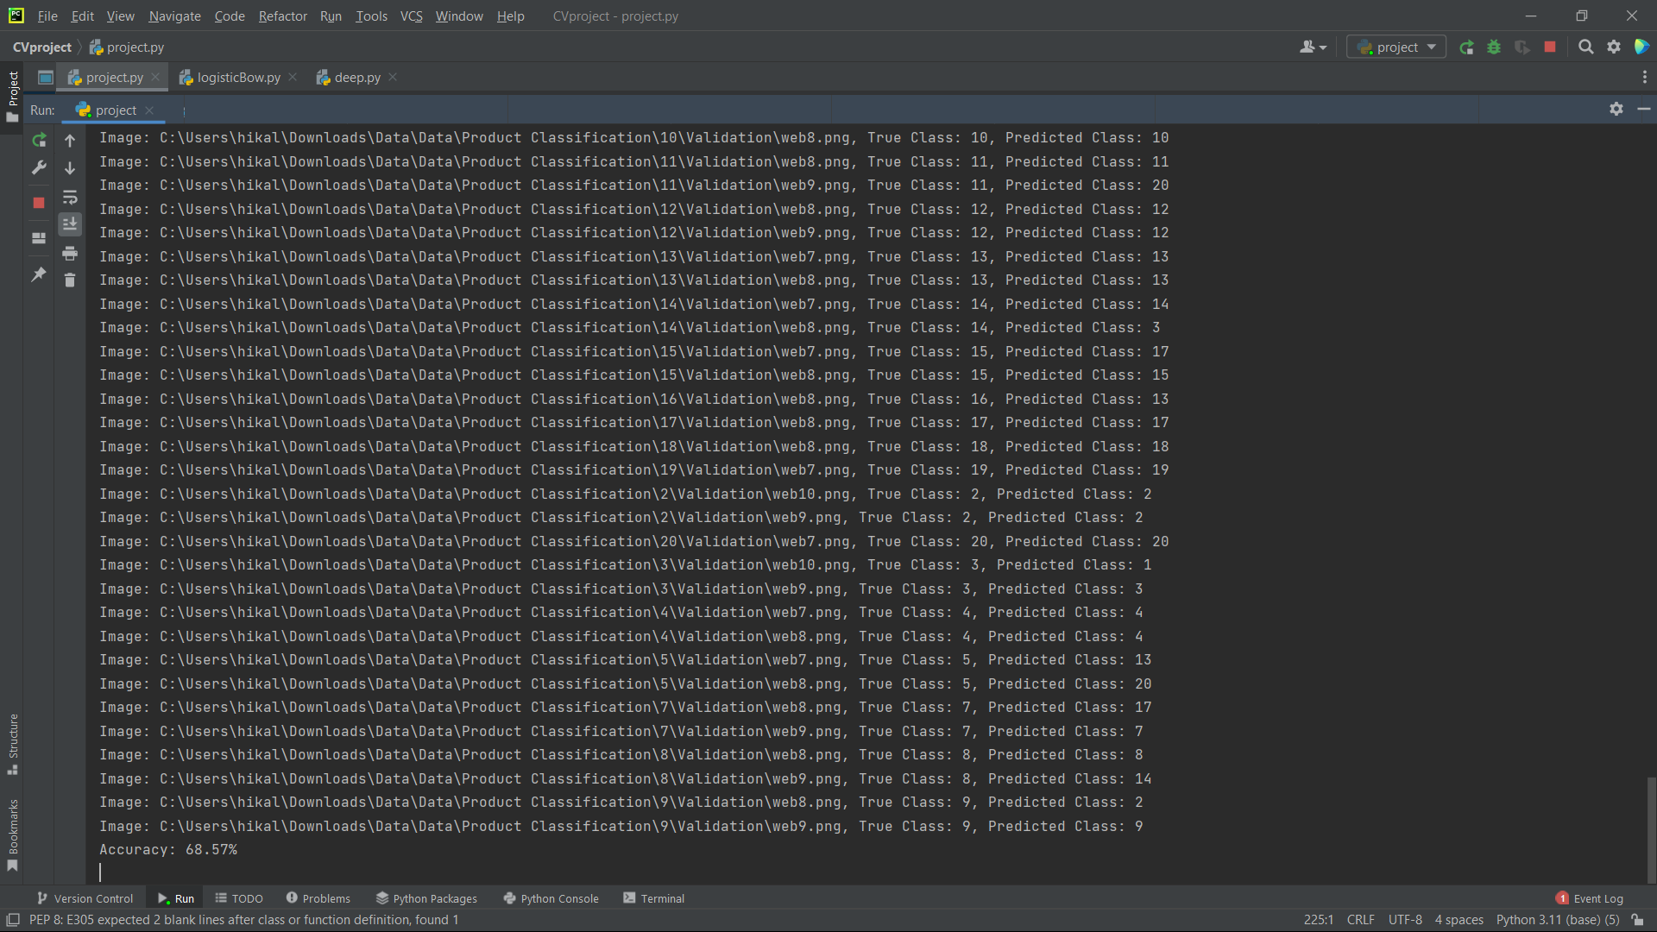

For Logistic regression(validation folders only):

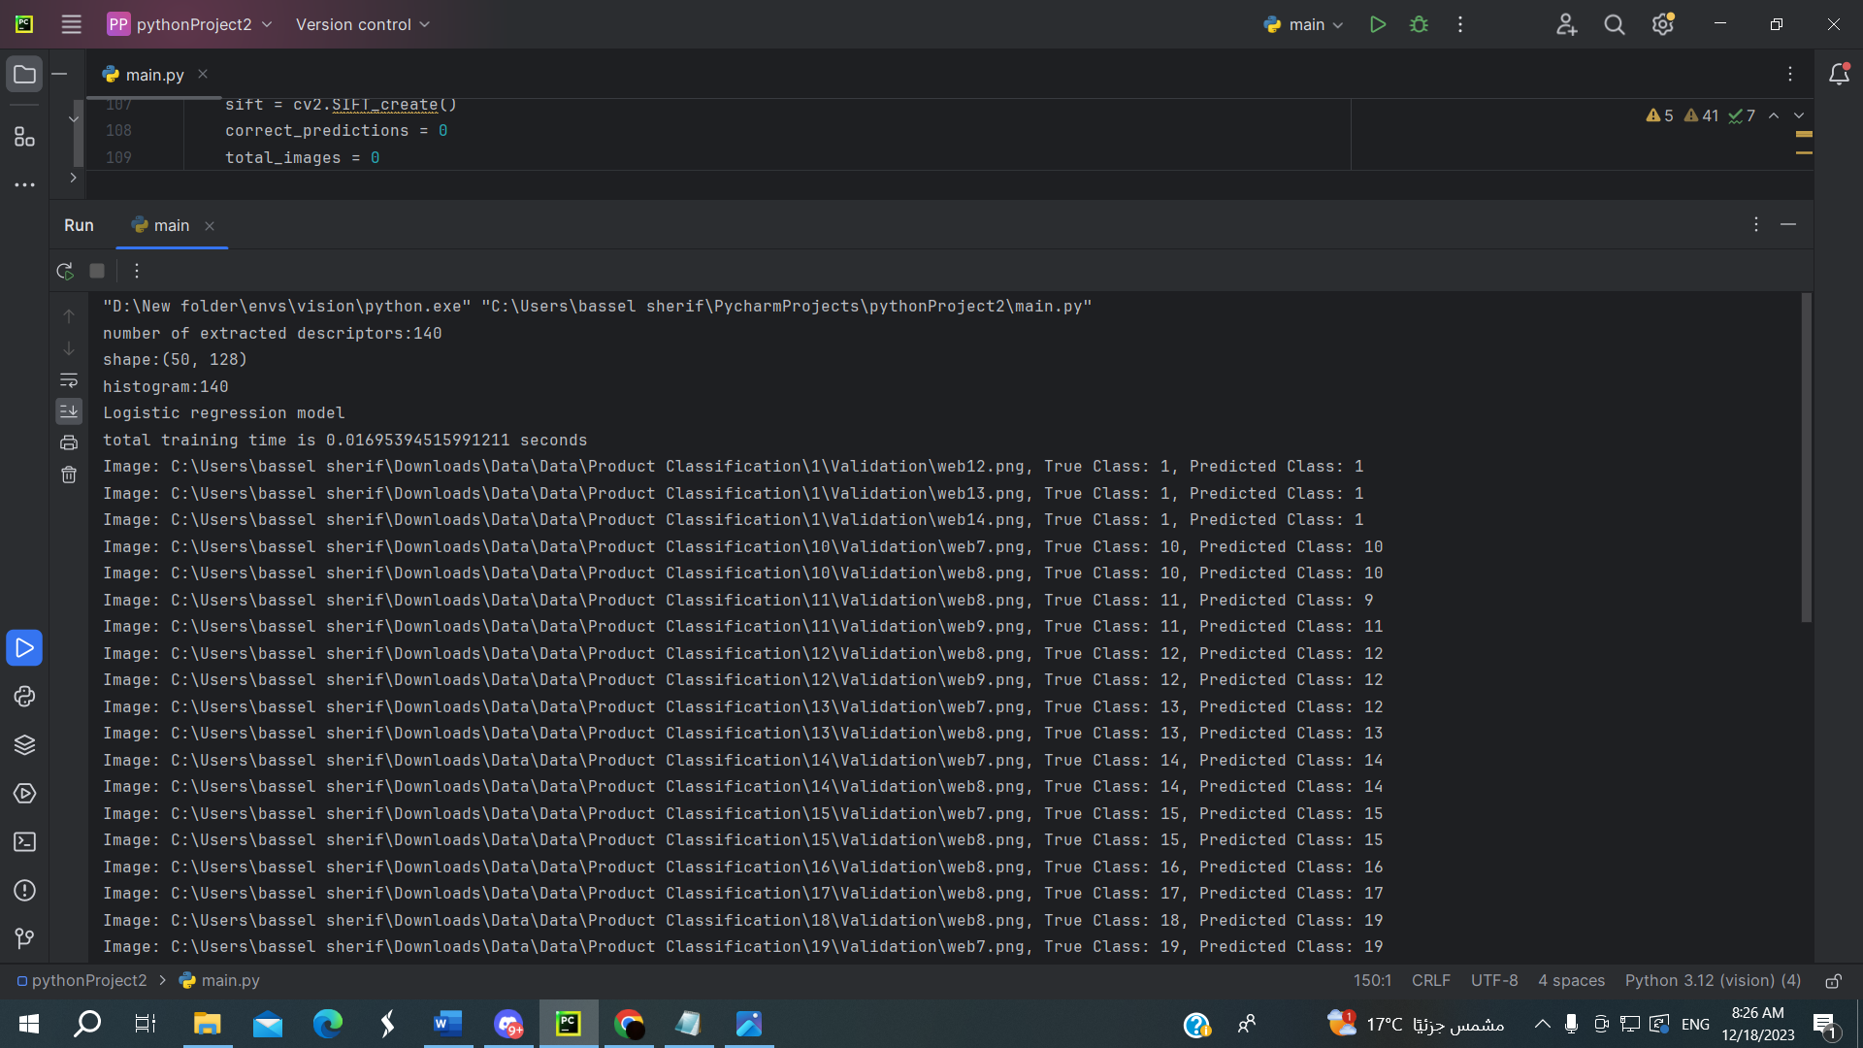

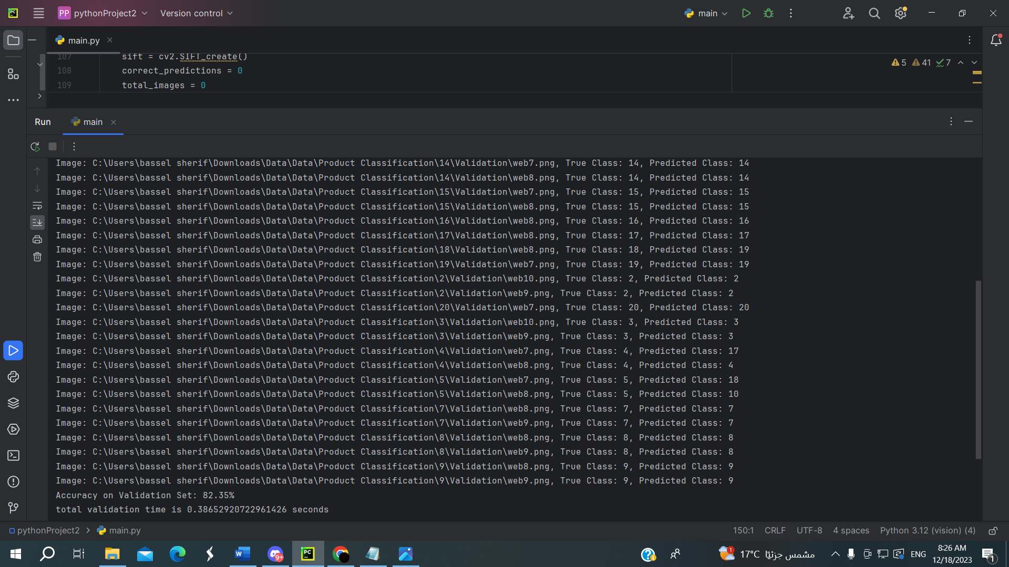

For Logistic regression(train and Validation folders):

